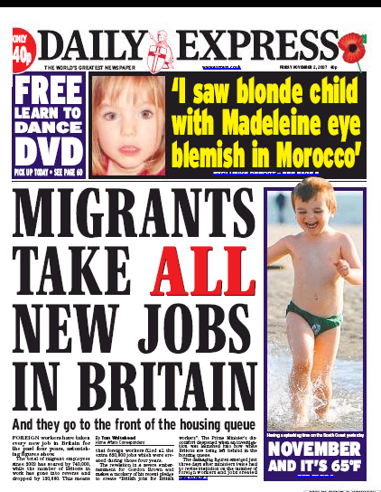
ANNEX 1-5
Press clipping in different languages

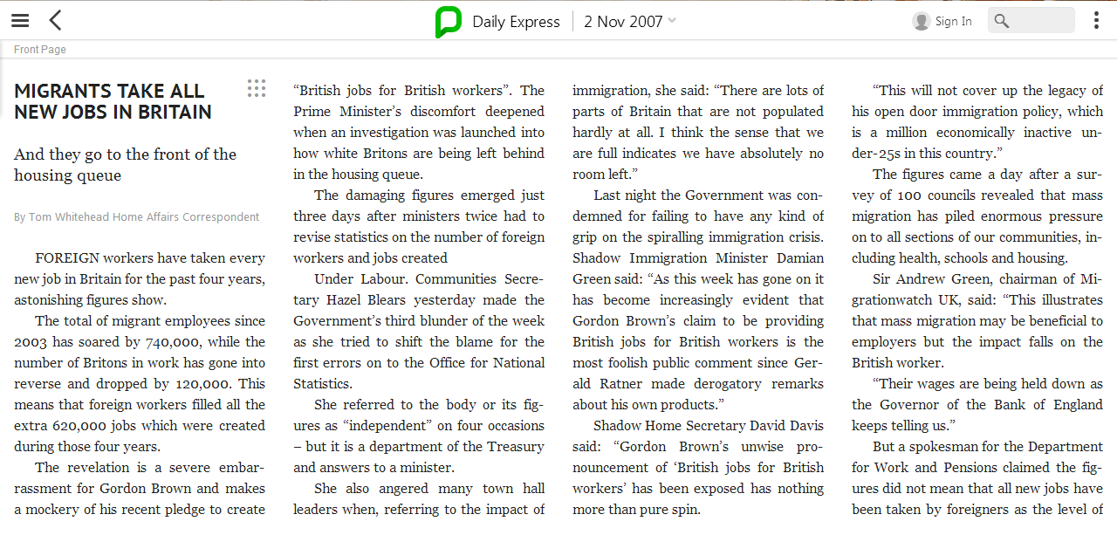

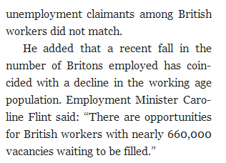

ANNEX 2

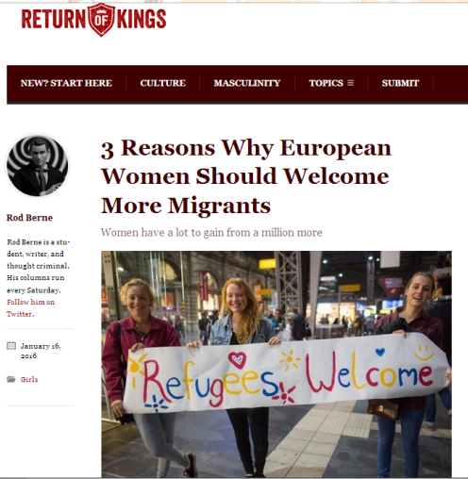
3 Reasons Why European Women Should Welcome More Migrants Women have a lot to gain from a million more
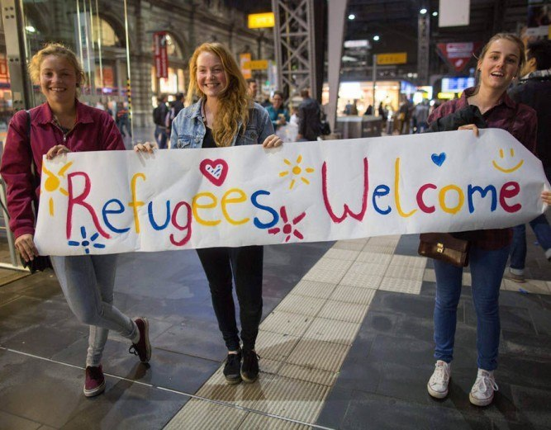

January 16, 2016

Some have pointed to the recent events in Germany, Denmark, and across Europe and gently wondered whether Western women are under increased threat. Some have even gone so far as to say that women’s odds of being raped have surged as a result of allowing limitless numbers of men to enter their countries and enrich their culture. In this article, I will show why this is false and give three reasons why welcoming several million more migrants is in fact the best possible choice for women.

1. More Dating Options
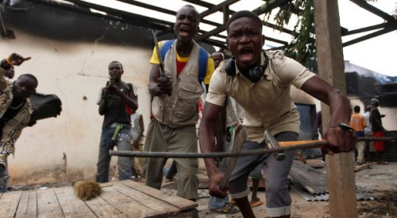
They can’t wait to meet you.
The demographic make-up of the refugees is overwhelmingly male. About 62% of the 1.5 million migrants that have traveled to Europe in 2015 are young, strong, self-confident men. Is it any wonder why women should welcome them? A little under a quarter, 22%, are children and only 16% are women. That means that European women have an additional 1 million men for potential consenting sexual partners. Choice is a good thing, and by urging more young men to voyage to Europe women will have more options.

2. Less Patriarchy
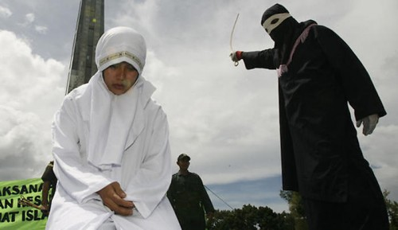
They do not support male domination.
In our free and open society, these migrants would fit in. They’ve proven to be fans of group sex not only with women, but young males as well. This sort of sexually libertine behavior is healthy for post-sexual revolution modern women.
It’s obvious that the patriarchy is a constricting system that suppresses women’s right to express their sexuality. The migrants have no problem having group sex in a public square with one or more women, signaling that they are not suppressors of female sexuality, but rather benevolent enablers. Allowing more sexually open migrants into the West will allow us to dismantle the patriarchy once and for all.

3. More Respect For Women

Respectful migrant courtship.
Of all the regions in the world, by far the most dangerous for women is the modern West. We have a problem, and it’s called rape culture. One in four women are viciously raped in college, which is why the enrollment numbers for female students is dwindling. At an Ivy League college a woman has a higher chance of being raped on her way to class than she does living to the age of 25. Compared to the only 6,000 reported rapes since the start of the Syrian civil war, our colleges are terrifying. The men coming from these lands will follow their religious code of peace and show women more respect, as they have already proven.
These men have never trivialized rape.
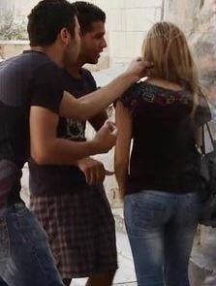
Over the last decade, Syria has experienced a massive rape crisis. One Syrian woman described how a group of Syrian army soldiers had come to her house in Homs, tied up their father and brother, and raped her and her sisters in front of them. The woman cried as she went on to describe how the soldiers opened their legs and burned their vaginas with cigarettes.
We should understand that this is the sort of violence from which migrants are desperately trying to escape. Islam, the religion of peace the migrants follow, is a well-known supporter of women’s rights. If you visit Islamic countries in the Middle East, you will experience a liberated feminist utopia that the West could only dream of.
Soon you won’t even need a passport to experience the benefits of this new and exotic culture.

ANNEX 3
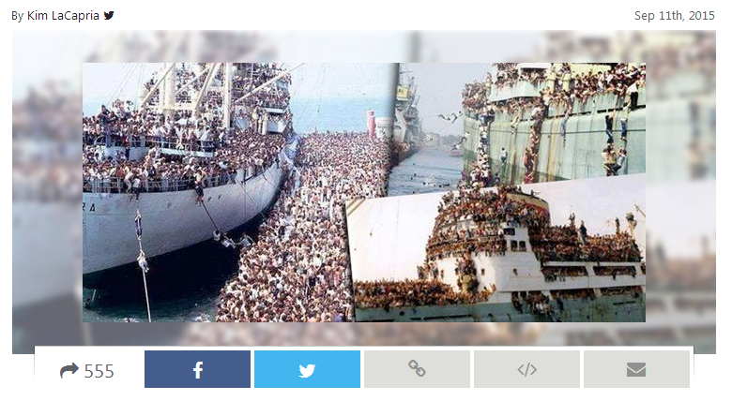
[Collected via e-mail and Imgur.com, September 2015]
A photograph depicts a tramp steamer carrying Muslim refugees from Libya to Italy.
What the mainstream, leftist media do not show us.
A tramp steamer leaving for Italy from Libya. And everyone on board gets accepted by the kind, loving, Politically Correct Europeans — who will soon find themselves overrun by people who mostly cannot speak the languages of host nations and have limited skills in areas needed by technologically advanced countries and thus can hardly contribute to the economies of their benefactors.
Worse, a floodtide of the Muslim way of life is hereby being imported — by people who refuse to integrate into new societies they infiltrate but instead soon start demanding that their way of life, their beliefs and their laws prevail.
The next step is a Muslim Europe.
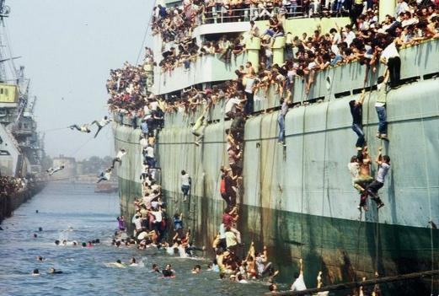

ANNEX 4
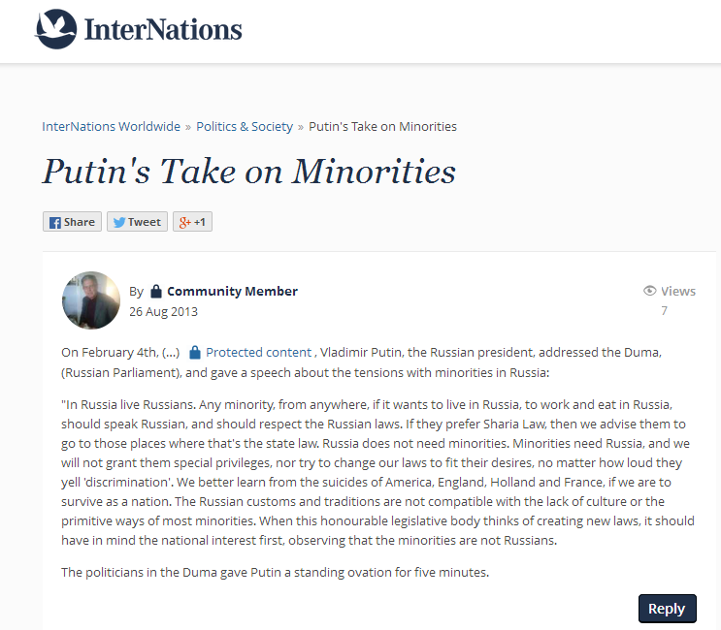
https://www.internations.org/world-forum/putin-s-take-on-minorities-967510
http://www.snopes.com/politics/soapbox/putinduma.asp

A February 2013 speech by Russian president Vladimir Putin demanded that Muslim immigrants speak Russian and conform to Russian culture.
On February 04, 2013, Vladimir Putin, the Russian president, addressed the Duma, (Russian Parliament), and gave a speech about the tensions with minorities in Russia :
“In Russia live Russians. Any minority, from anywhere, if it wants to live in Russia, to work and eat in Russia, should speak Russian, and should respect the Russian laws. If they prefer Sharia Law, and live the life of Muslims then we advise them to go to those places where that’s the state law. Russia does not need Muslim minorities. Minorities need Russia, and we will not grant them special privileges, or try to change our laws to fit their desires, no matter how loud they yell ‘discrimination’. We will not tolerate disrespect of our Russian culture. We had better learn from the suicides of America, England, Holland and France, if we are to survive as a nation. The Muslims are taking over those countries and they will not take over Russia. The Russian customs and traditions are not compatible with the lack of culture or the primitive ways of Sharia Law and Muslims. When this honorable legislative body thinks of creating new laws, it should have in mind the Russian national interest first, observing that the Muslim
minorities are not Russians.
The politicians in the Duma gave Putin a five minute standing ovation.
ANNEX 5
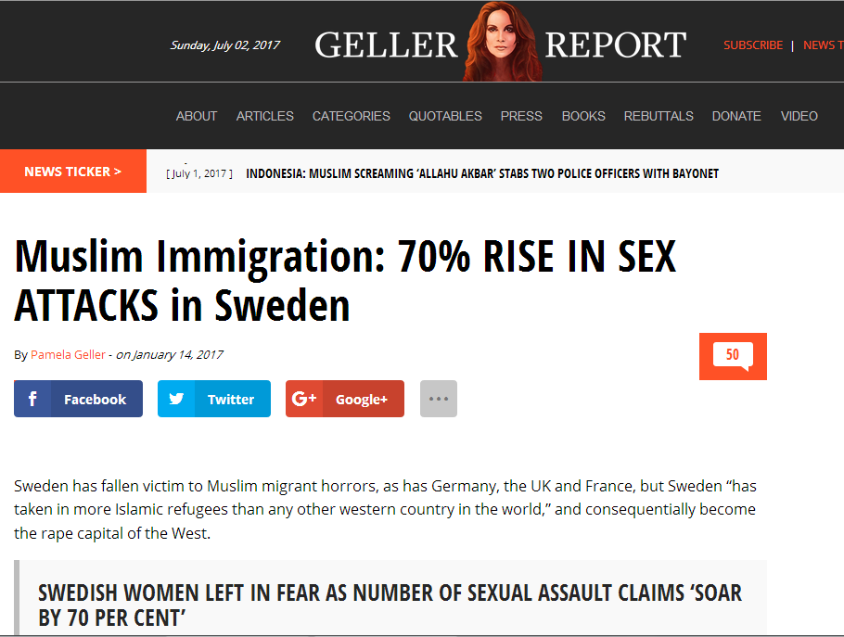
Muslim Immigration: 70% RISE IN SEX ATTACKS in Sweden
By Pamela Geller - on January 14, 2017
http://pamelageller.com/2017/01/muslim-immigration-70-rise-sex-attacks-sweden.html/
Sweden jihad
Sweden has fallen victim to Muslim migrant horrors, as has Germany, the UK and France, but Sweden “has taken in more Islamic refugees than any other western country in the world,” and consequentially become the rape capital of the West.

SWEDISH WOMEN LEFT IN FEAR AS NUMBER OF SEXUAL ASSAULT CLAIMS ‘SOAR BY 70 PER CENT’
THE NUMBER OF SWEDES WHO CLAIM TO HAVE SUFFERED SEXUAL ASSAULTS HAS SURGED BY 70 PER CENT IN JUST TWO YEARS, ACCORDING TO OFFICIAL DATA.
By Will Kirby, The Express, January 12, 2017:
In 2014, just one per cent of Swedish people said they had been sexually attacked, rising to 1.7 per cent in 2015, which equates to more than 129,000 people.
The increase in sexual assault cases is having a devastating effect on the lives of Swedish women, with between 13 and 14 per cent saying they were afraid of venturing out in the evenings, according to new date.
Around 22 per cent of women said they are concerned about sexual assault, as well as eight per cent of Swedish men.
The data was revealed in an annual survey of around 12,000 people by he Swedish National Council for Crime Prevention (Brå), an agency working under the Ministry of Justice.
Director general of the National Council, Erik Wennerström, said: “The difference between women’s and men’s insecurity is not acceptable in the society that we want.”
The percentage of sexual assault victims in Sweden has hovered around the one per cent mark between 2005-2012 before a sharp jump to 1.3 per cent in 2013.
While numbers dropped in 2014, the following year saw a huge surge in alleged sexually assault victims, with women aged between 20-24 considered the most at risk.
he survey also found the most common location for sexual attacks is in public places, and the perpetrator is often unknown to the victim. The sexual assaults recorded were wide-ranging, from minor offences such as indecent exposure to rape and other very serious crimes. Major public events in Sweden, including music festivals, have been highlighted as areas where young women face a high chance of sexual harassment. Some Swedish women claim they are afraid to go out at night The country has seen a wave of sexual assaults in recent months, some of which have been committed by migrants who have recently arrived in Sweden. Swedish author Katerina Janouch recently claimed Sweden was struggling to cope with the migrant crisis. Speaking to Aftonbladet, she said: “I’m not saying it’s the refugees’ fault but we are facing a crisis in migration issues.“I want to have a debate about what our society should look like. About how we allocate resources in our own country, how we distribute taxpayers’ money and which political decisions should be made.

